**ENTREGABLE 1**

**Tabla Users**

**Método POST (create)**

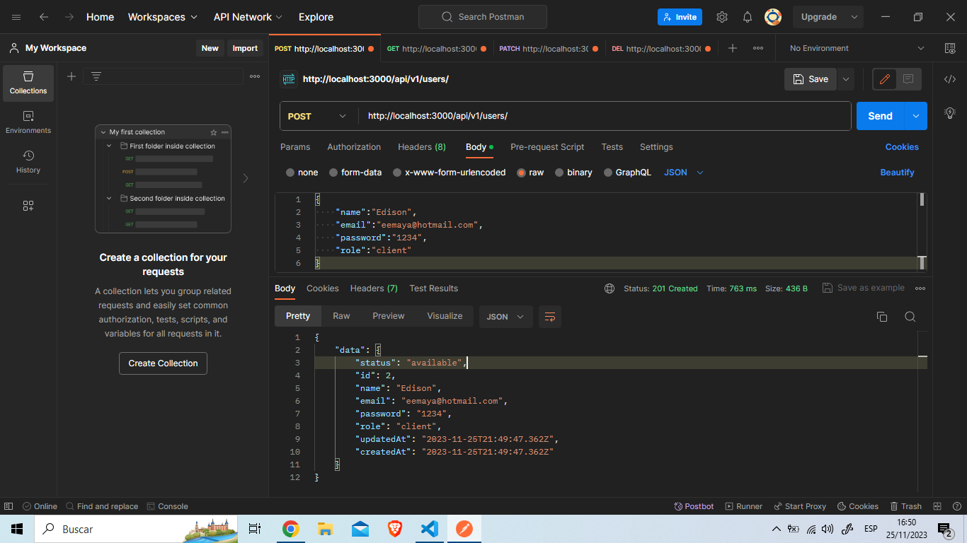

**Tabla Users**

**Método GET (FindAll)**

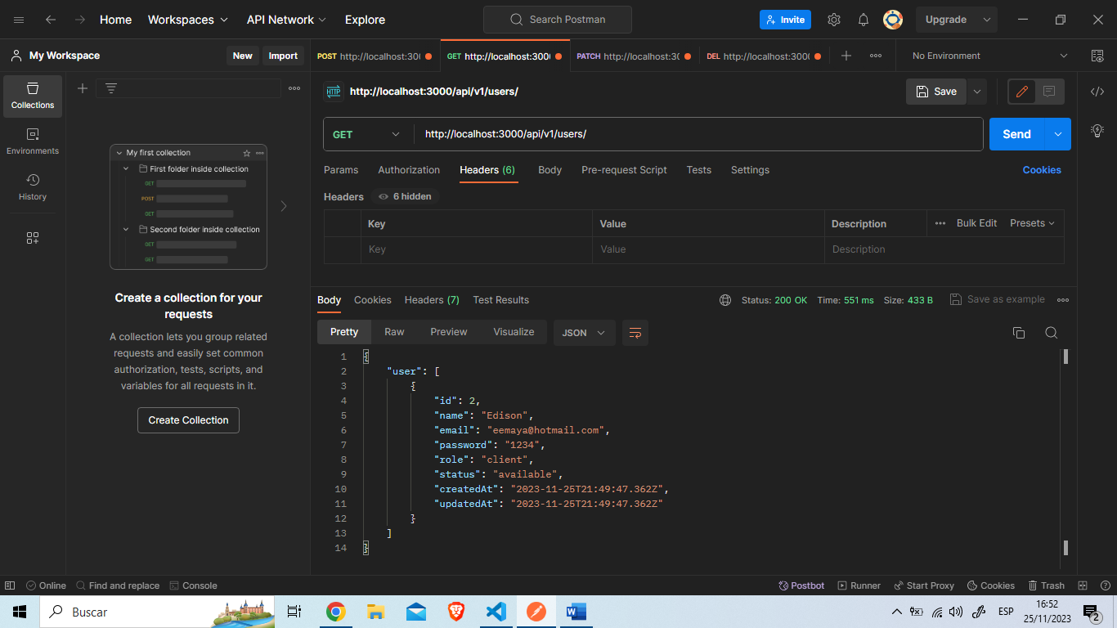

**Tabla Users**

**Método Patch (update)**

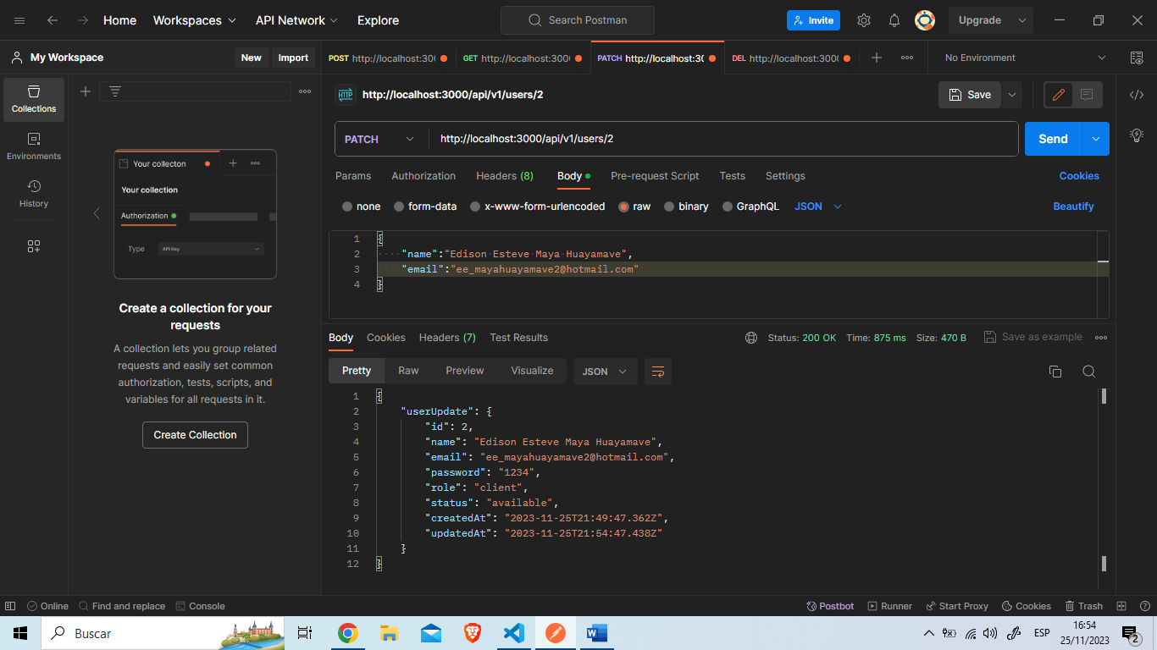

**Tabla Users**

**Método GET (FindOne)**

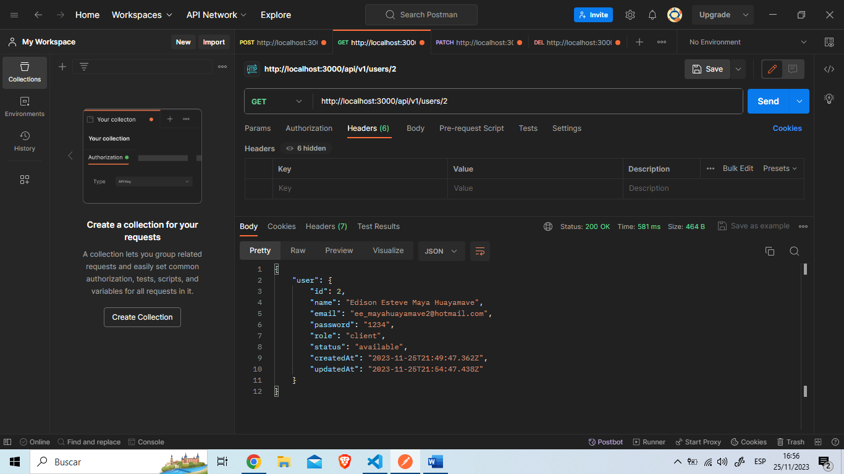

**Tabla Users**

**Método DELETE (delete)**

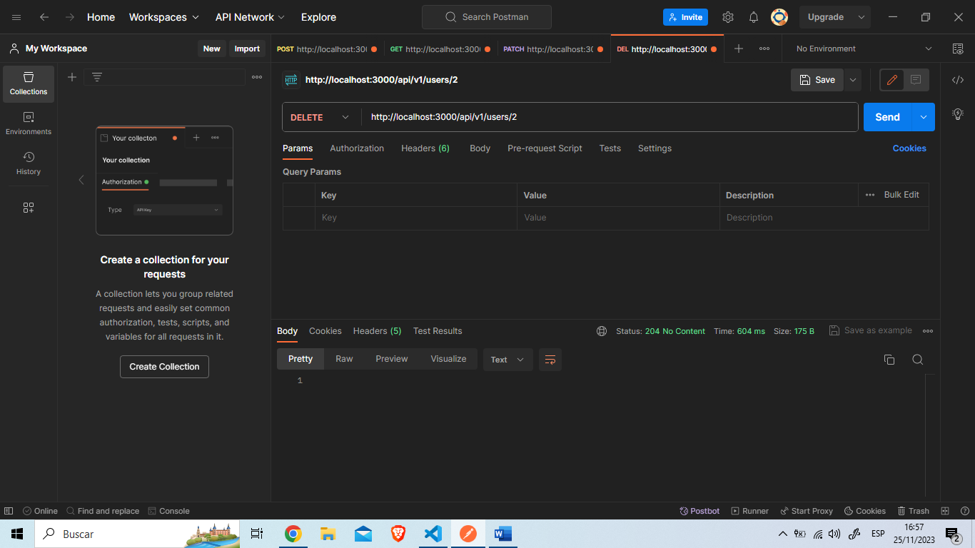

**REGISTROS TABLA USERS**

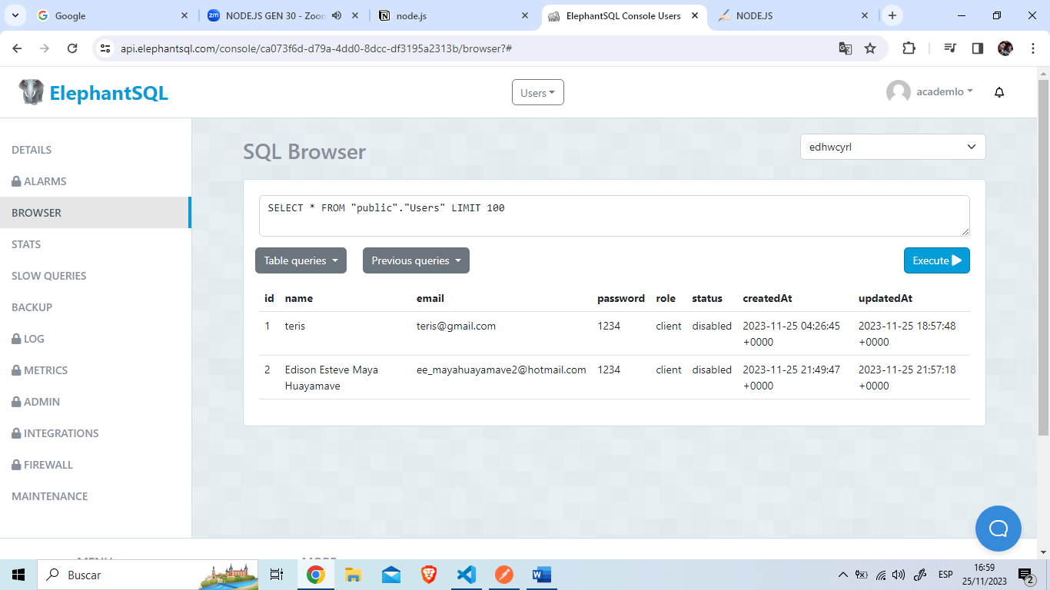

**Tabla Repairs**

**Método POST (create)**

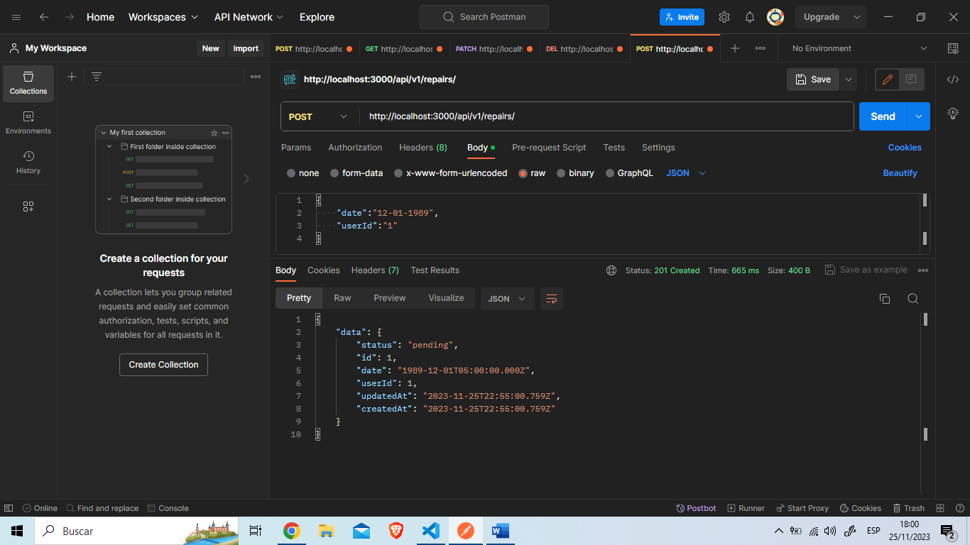

**Tabla Repairs**

**Método GET (FindAll)**

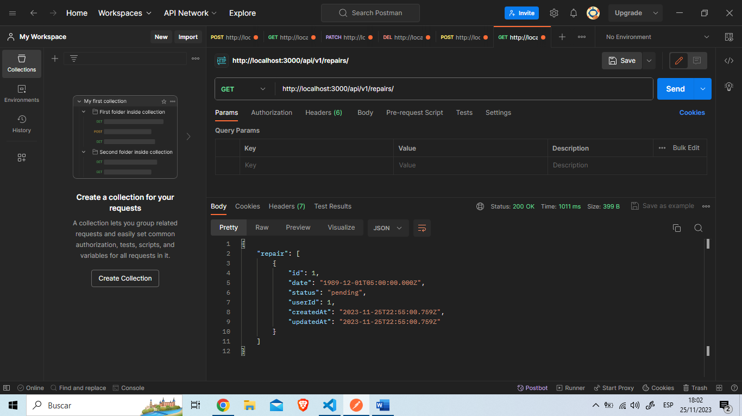

**Tabla Repairs**

**Método PATCH (update)**

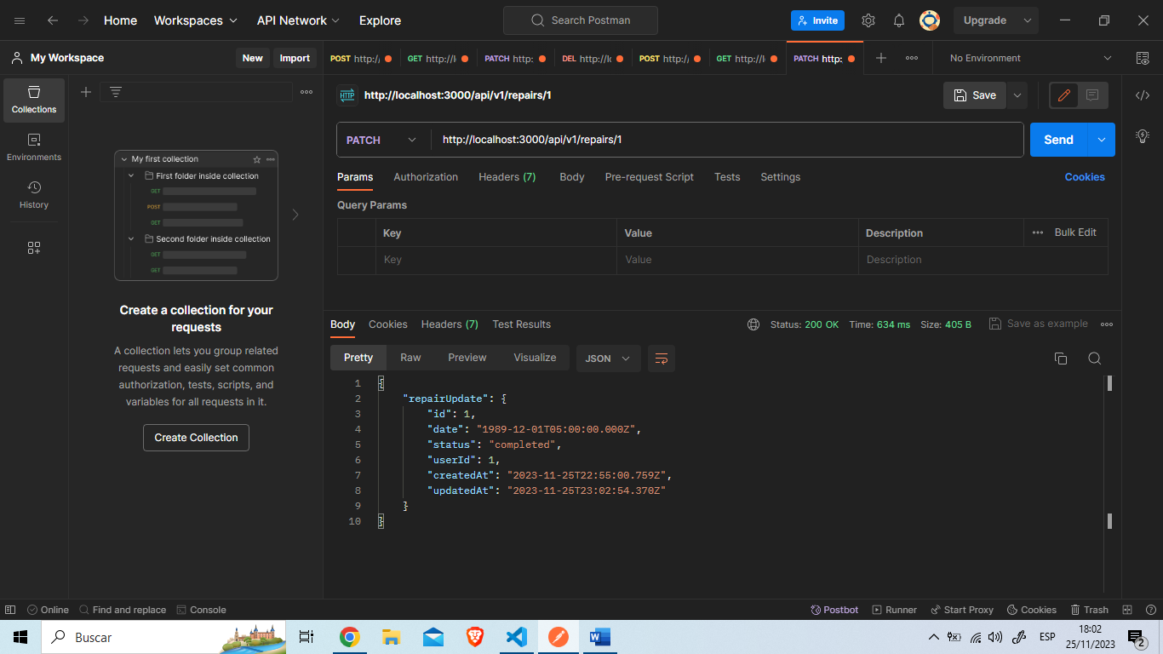

**Tabla Repairs**

**Método GET (FindOne)**

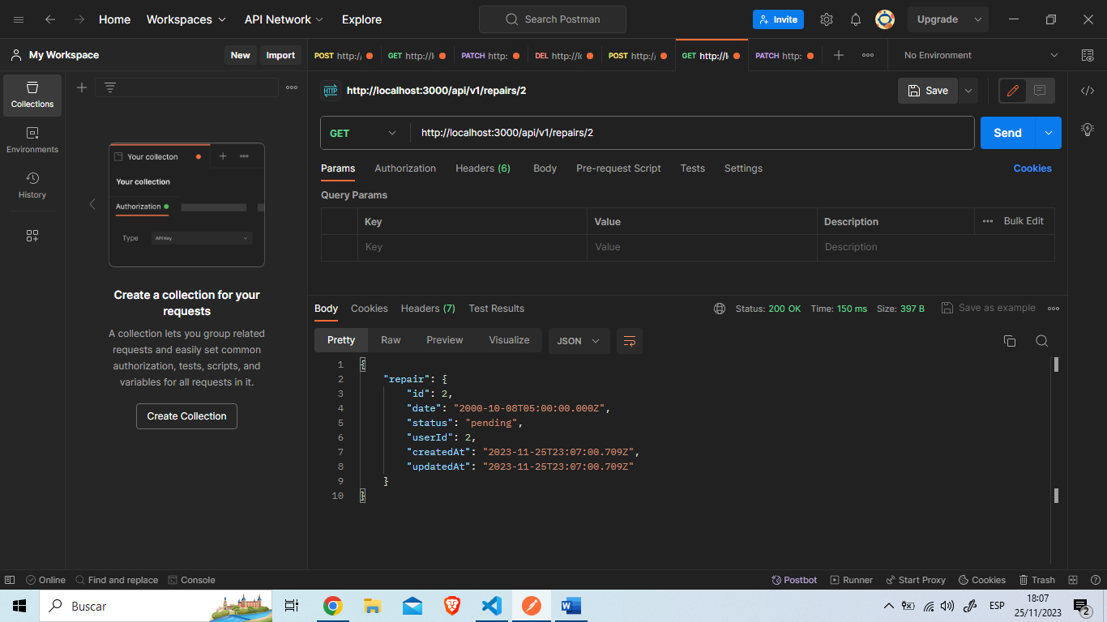

**Tabla Repairs**

**Método DELETE (delete)**

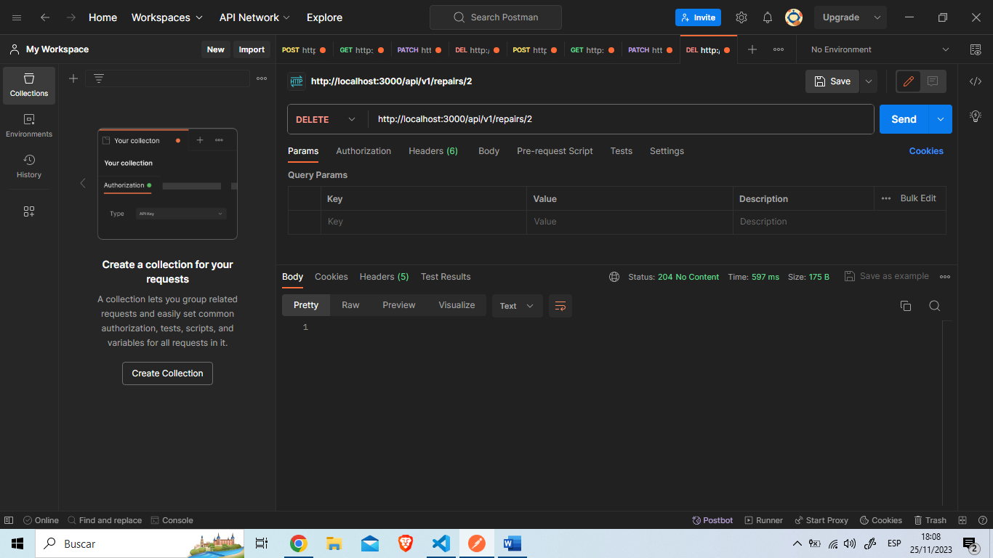

**REGISTROS TABLA REPAIRS**

